
LOAN INVESTMENT MEMORANDUM
642 Mountain Village Blvd, Mountain Village, CO 81435

Transaction Overview
Castellan will provide a note-on-note loan of $2,400,000 secured by an assignment of the underlying loan encumbering a property located in Mountain Village, Colorado. The subject property comprises a 36,319-square-foot (0.83-acre) land site with moderate slopes, currently improved with a gravel parking lot and walkway. The total buildable square footage is 179,091. The underlying sponsors will either refinance with a construction loan or sell the entitled land.

Sponsorship Overview
- Business background: According to the resume submitted by the borrower, Mr. Yonel Devico serves as Principal Manager of Crosby Capital USA, a mortgage investment company where he has been involved in the acquisition and workout of more than 300 loans with an aggregate value exceeding $100 million. His experience includes trading first and second mortgage positions, managing unsecured notes, overseeing rehabilitation projects, and executing debt restructuring and note reperformance strategies. Mr. Devico also has a legal background with experience managing complex bankruptcy and foreclosure proceedings. He is a graduate of Audencia Business School, holds a Master of Science in Real Estate Development from Columbia University, and has completed the Real Estate Executive Program at Harvard Business School.
- Personal financials: Based on the personal financial statement shared by the borrower, Mr. Devici has a net worth of approximately $6.4MM.
- Background & credit check results: Castellan engaged Eaglescreen to perform civil and criminal record checks on the borrower. Based on the results, the borrower is not involved in any pending civil or criminal cases that are of concern to Castellan. In addition, online searches did not reveal any derogatory or adverse information about the sponsors. Additionally, the credit report indicated that the sponsor has a strong credit score of +770.

Submarket Overview:
According to the appraisal report, the subject property is located within the Mountain Village/Telluride resort submarket in San Miguel County, CO, a premier luxury ski destination characterized by high-end hospitality and residential developments, limited developable land, and strong barriers to new supply. The area benefits from direct integration with the Telluride Ski Resort and proximity to luxury hotels, condominiums, and resort amenities.
As of Q1 2026, the Colorado ski area luxury hospitality market reported a trailing twelve-month occupancy rate of approximately 50.6%, with ADR averaging approximately $658 per night. Within the competitive luxury hotel set analysed in the appraisal, occupancy averaged approximately 53.3% with ADR exceeding $1,025 per night, reflecting continued demand for ultra-luxury hospitality product despite broader market normalization trends.

Business Plan
The future development plan will consist of 50 hotel rooms, 20 condominiums, 31 lodge units, 18 employee dormitory units, two employee apartments, restaurant space, retail/commercial space, structured parking, and related amenities. The Senior Lender, Crosby Capital, recently entered into a forbearance agreement with the underlying borrower (the property owner) which brings the underlying note current with a unpaid principal balance of $4.153MM. The underlying sponsors will either refinance with a construction loan or sell the entitled land.

Risks & Mitigants
- LTV Risk: Castellan’s estimated Loan-to-Value ratio will be 27%, based on the ‘As Is’ appraised value provided by Partner Valuation. Castellan supports this value based on the firm’s independent underwriting and analysis of comparable sales and rentals. We believe that the strong basis in the loan can facilitate a potential sale of the Note in the event of a default. Castellan has developed relationships with defaulted note buyers and has sold several non-performing loans in the past.
- Sponsor Risk: This is Castellan’s first loan with Mr. Devico; however, based on the resume submitted by the borrower, he has extensive experience in mortgage investments, loan workouts, and debt restructuring through his role at Crosby Capital USA. He has been involved in the acquisition and management of more than 300 loans with an aggregate value exceeding $100 million, with experience spanning first and second mortgage positions, unsecured notes, and rehabilitation projects. Castellan performed a background check on the sponsor which revealed no prior defaults, bankruptcies, or liens.
- Environmental Risk: Castellan engaged Partner Valuation for an HRDR on the property. The report revealed no recognition of environmental conditions and suggested no further action or remediation.
- Insurance Risk: At closing, the property will be covered with general liability coverage of $5,000,000 per occurrence. The sponsor will have a builder’s risk policy with a coverage always amount greater than Castellan’s loan principal. At the time of this memo, the sponsor is working on binding their policies. In reviewing insurance coverage, the firm relies on each of the following: the insurance coverage for similar types of properties in its existing portfolio of loans, and an independent review and recommendation from York International, which is Castellan’s main insurance agent.

Loan Financials
Please see below for an overview of relevant loan metrics and other financial information about the property and transaction:

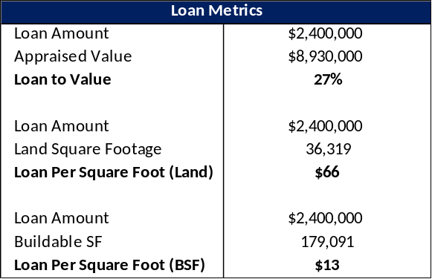
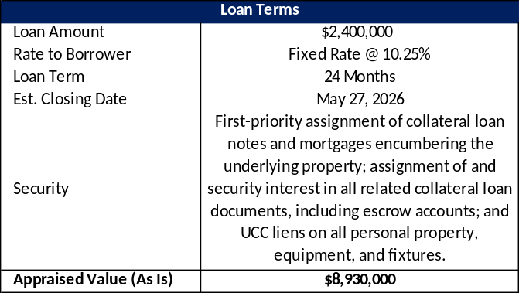

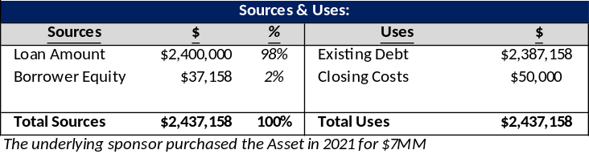

Investment Highlights
Castellan believes this is an attractive investment opportunity for the following reasons:
- This loan presents an attractive risk-adjusted return through a first-priority assignment of the collateral loan notes and mortgages encumbering a land property in Mountain Village, CO.
- Castellans ‘As Is’ LTV is approximately 27%.
- Mr. Devico has extensive experience in mortgage investments, loan workouts, and debt restructuring through his role at Crosby Capital USA, and has overseen the acquisition and management of more than 300 loans with an aggregate value exceeding $100MM.
- In the event the company comes into possession of the collateral, Castellan believes that it would have the potential to foreclose on the property and, if successful, take title at an attractive overall cost basis. Unlike traditional lenders, Castellan has the knowledge and infrastructure in place to successfully renovate, recapitalize and take ownership of the property.
Pictures

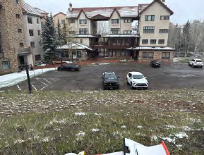

Map

